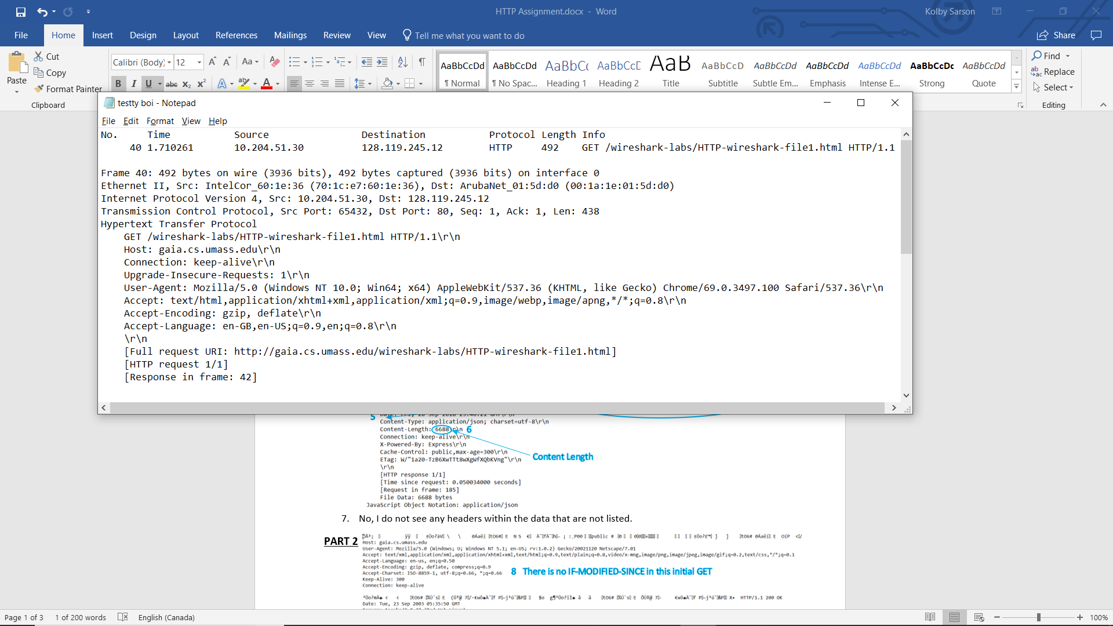**PART 1**

1

Browser Running

3

My IP

Server IP

Languages Accepted

2

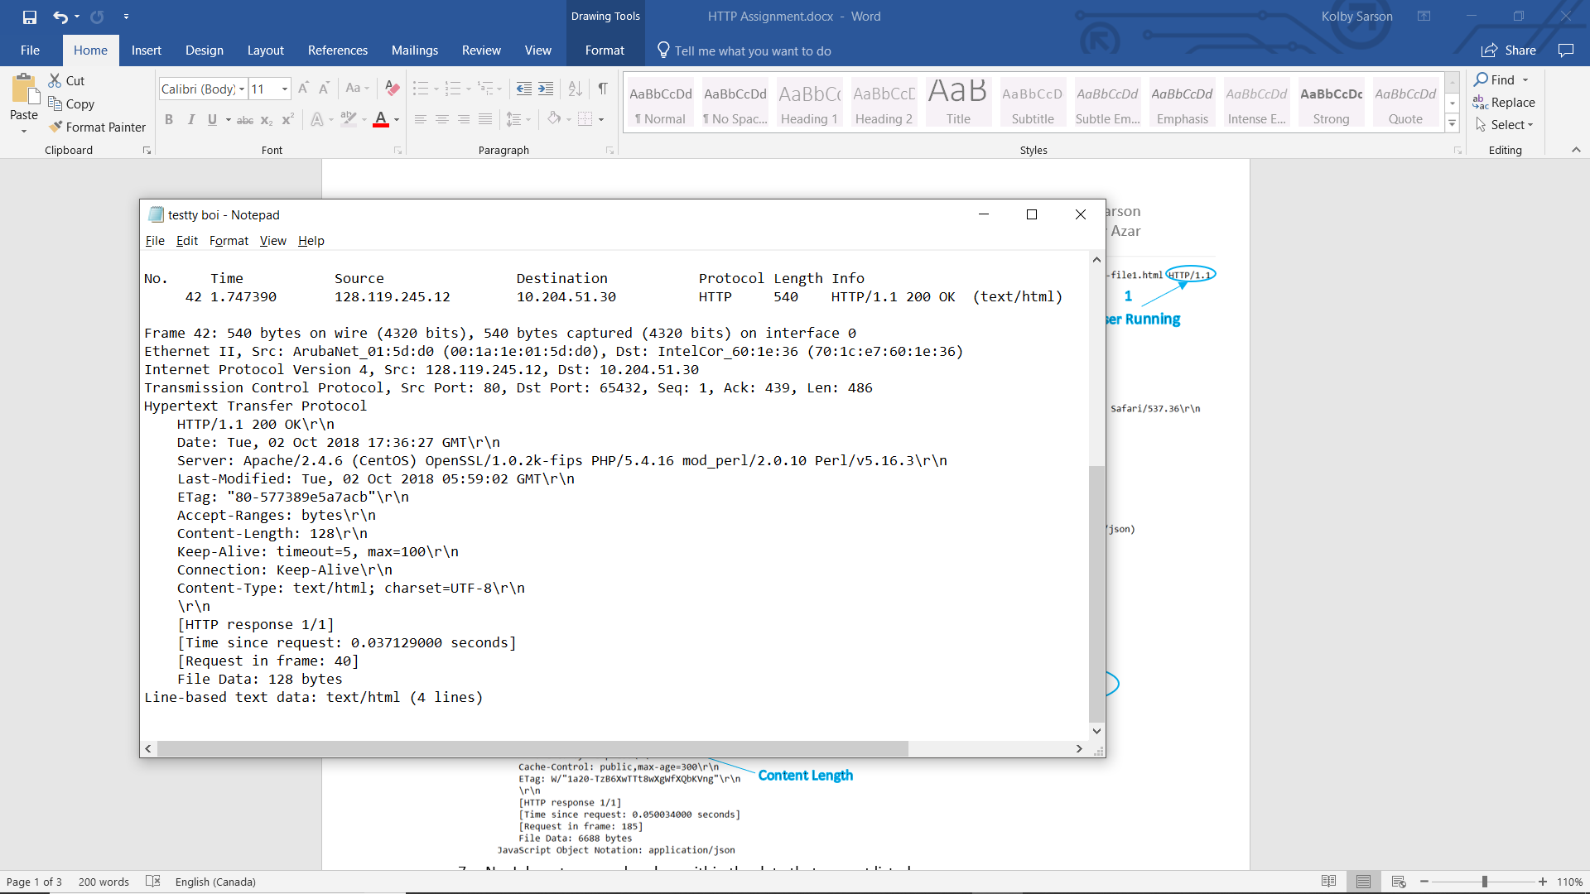

4

Return Status

1

Server Running

5

6

Last-Modified

Content Length

1. No, I do not see any headers within the data that are not listed.

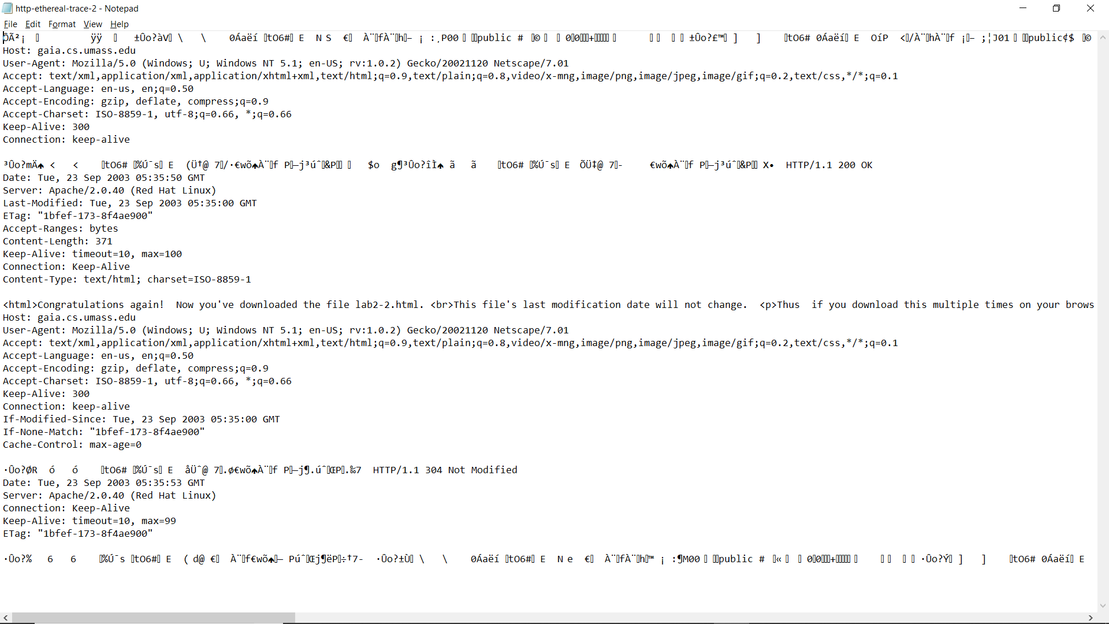**PART 2**

8 There is no IF-MODIFIED-SINCE in this initial GET

9 Text from response to initial GET

10 Next GET has IF-MODIFIED-SINCE

11 Has not been modified, so text is not returned

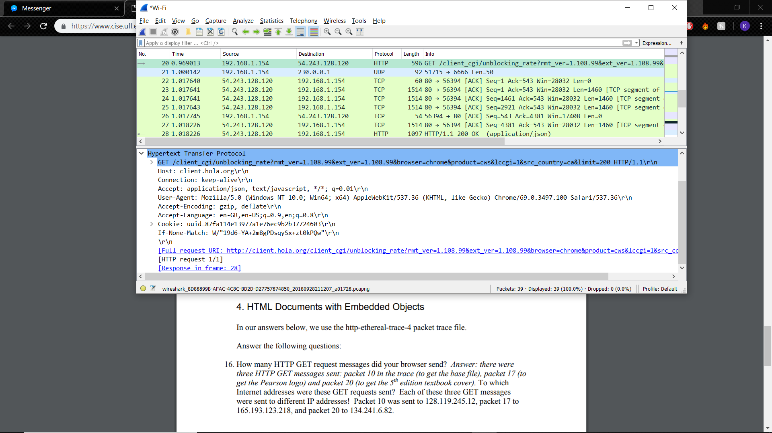**PART 3**

1. There is 1 GET message numbered Packet 20.
2. Packet 23.
3. 200 (OK).
4. 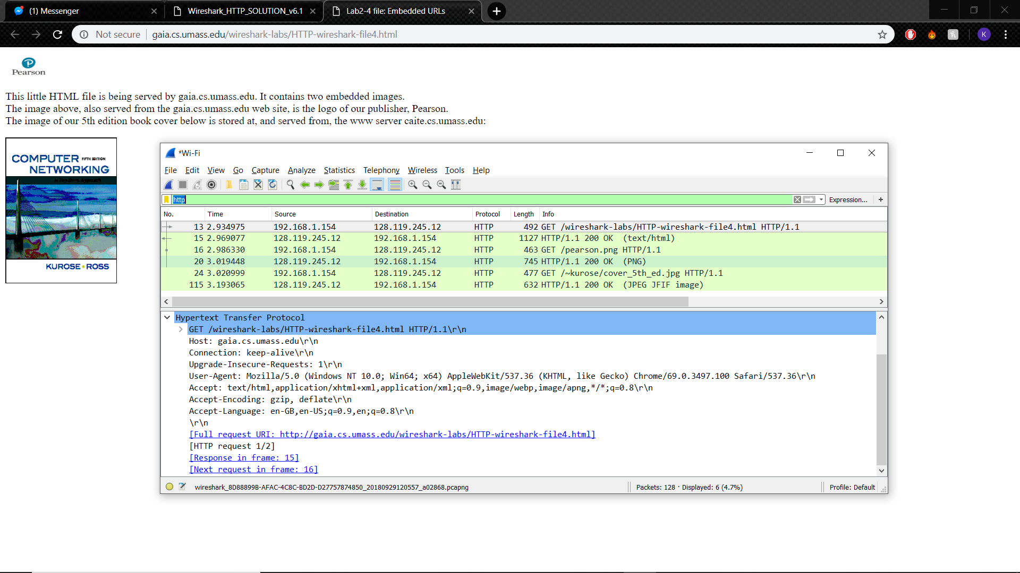4 (Packets 23, 24, 25, 27).

**PART 4**

1. There were 3 GET messages all sent to the IP address 128.119.245.12.
2. The two images were downloaded serially, seen by the .png packet request and response being packets 16 and 20, whereas the .jpg pack request and response being packets 24 and 115. Since the response to the .png request came before the .jpg request, I can see that they were done serially.

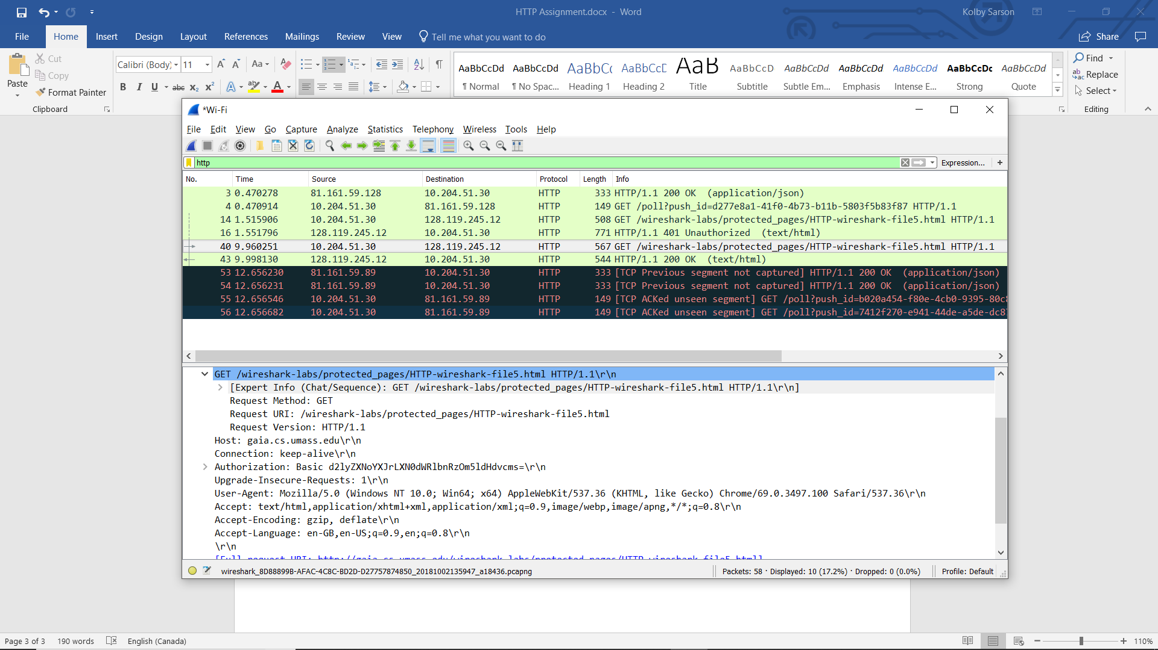**PART 5**

1. Packet 14 contains the first GET and packet 16 contains the response, which is “401 Unauthorized.”
2. The following GET includes Authorization: Basic.